Missing Source Field
We encountered a problem while importing a citation which had no source field.
PMID 21882460 was retrieved for Cannabis and Cannabinoid search and while importing we got the following message:
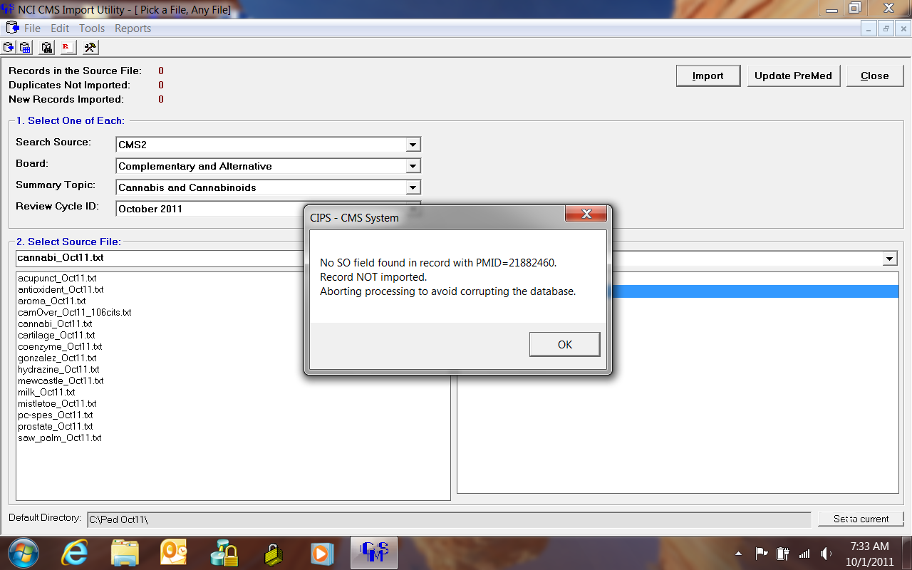
On researching the citation it is discovered that this citation is not a journal article, but a book chapter.
After removing the citation from text file, we were able to import the remaining citations.
Another accidental discovery was during updating Pre-Medline citations in CiteMS. We found similar citations in CitedMS imported in August 2010 without an error, but could not be updated due to no source field. These citations are PMID 20641716, 20641321, 20806450, 20681080. There might be few more citations without SO field in CiteMS.
We need to add a feature in our search strategy to exclude the citations with Publication type Book Chapter. This PT is added recently and still does not work for searching PubMed. We will have to wait till it becomes functional.
So far we were adding only journal articles from PubMed and we assume that this will be the case in future, but do we want to keep open the possibility of adding book chapter or other types of citations in CiteMS?
Note: We had come across non-journal PubMed citations which could not be imported to CDR. These were added manually.

